The cure assembly instructions draft
Section 1: Print Parts and Install Heat-Set Inserts
- 3D print all 9 parts (1X C1-C9,). STL files are located [here]( https://github.com/kelvinchow23/the-cure/tree/main/mechanical/3D%20prints%20and%20CAD%20files/stl)
- Install heat set inserts for the following:
  - Tray [C1]
    - m3 inserts on the top [4X B24]
    - m4 inserts on the sides [4X B25]
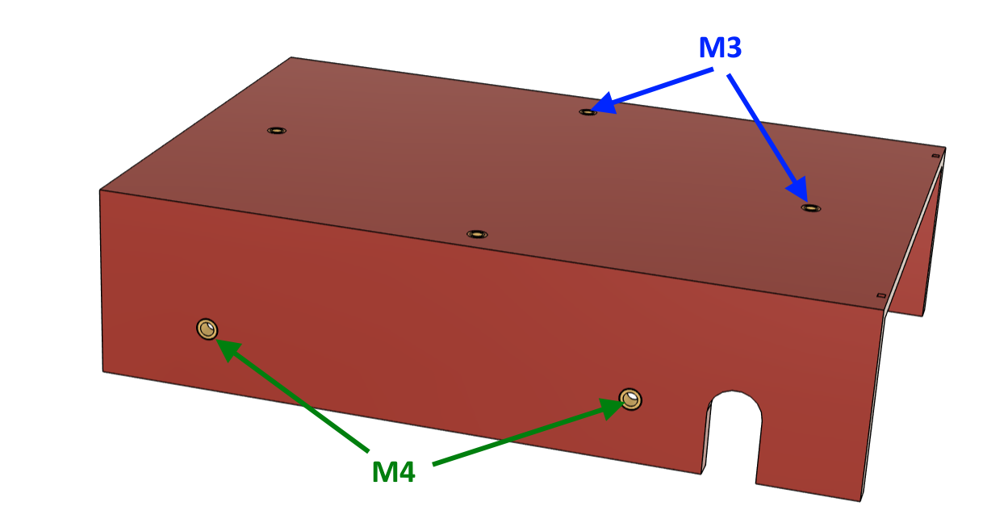
  - actuator bracket [C2]
    - m4 inserts as shown below [5X B25].
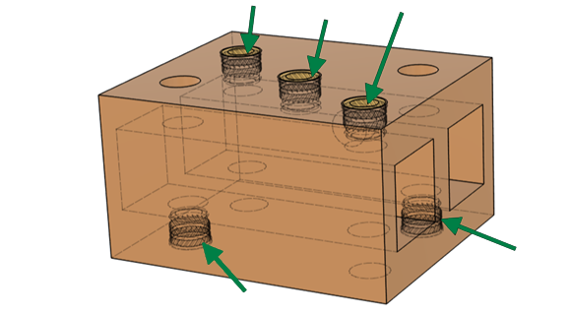
  - electronics mounting plate [C4]
    - m3 inserts [6X B24].
  - UV inner base [C6]
    - m3 inserts on the bottom and back [8X B24]
    - m4 inserts on the sides [12X B25]. Note: these need to be installed from the outside and pushed all the way flush to the inner surface
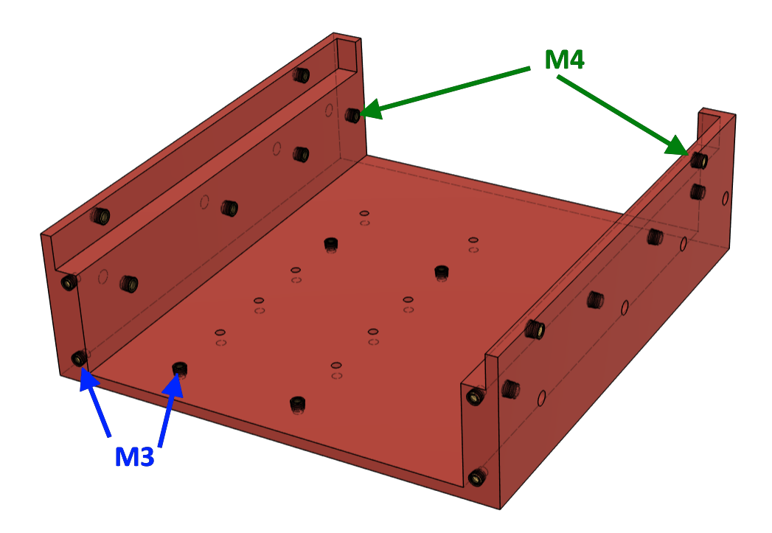
  - back connector panel [C9]
    - m3 inserts [2X B24]
    - m4 insert [1X B25].
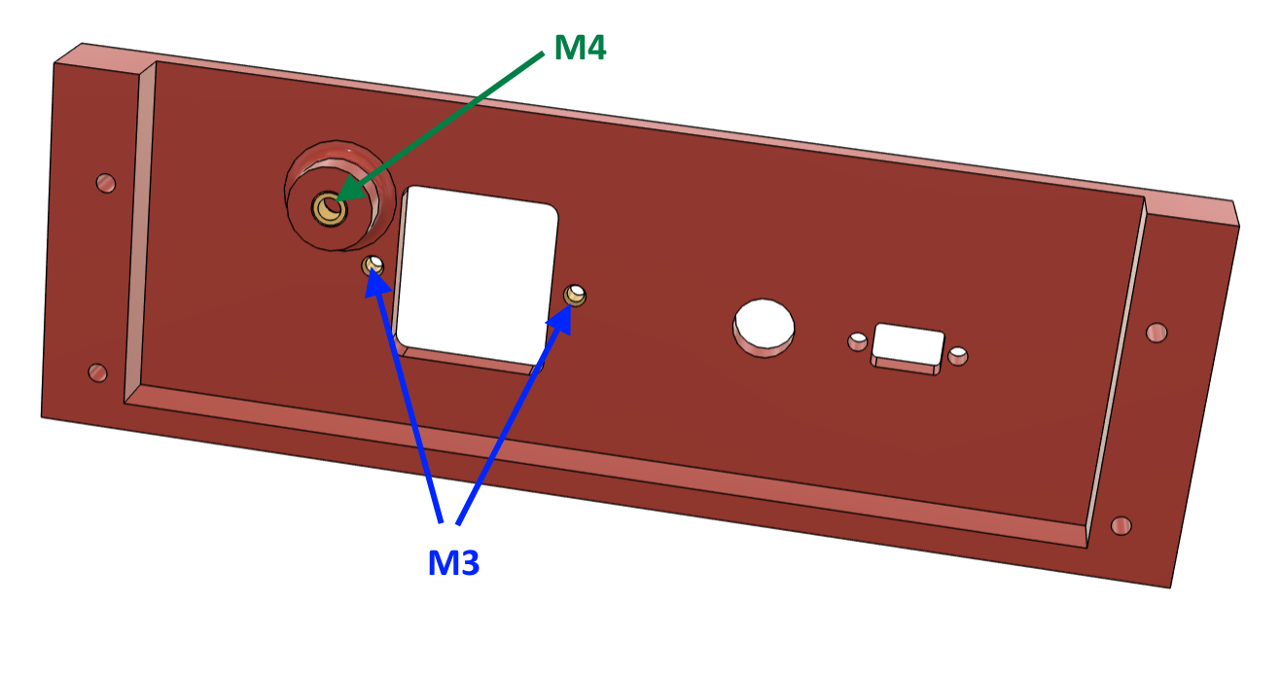

Section 2: Build Custom Cables
There are 5 custom cables to build.
Cable # | From | To | Description
E1 | WAGO + DC power (AC L + GND) | UV lamp | AC receptacle for UV lamp
E2 | Power entry module | Power supply (AC) | Feeds 120VAC to the DC power supply
E3 | Power supply (DC terminals) | Electronics board | Delivers 5V/12V to custom electronics
E4 | WAGO | AC relay | Neutral wire to relay
E5 | Power supply (AC neutral) | WAGO | Neutral line to WAGO connector

- Build cable E1: UV lamp receptacle
  - Take the power cord [B29] and measure 50cm from the connector and cut it. (Do not throw away the cable ends as they will be used for cable E2)
  - On the cut end, remove about 6cm off the black jacket and trim each of the 3 wires about 1cm.
  - Crimp on spade connectors [2X B31] to the green and white wires.
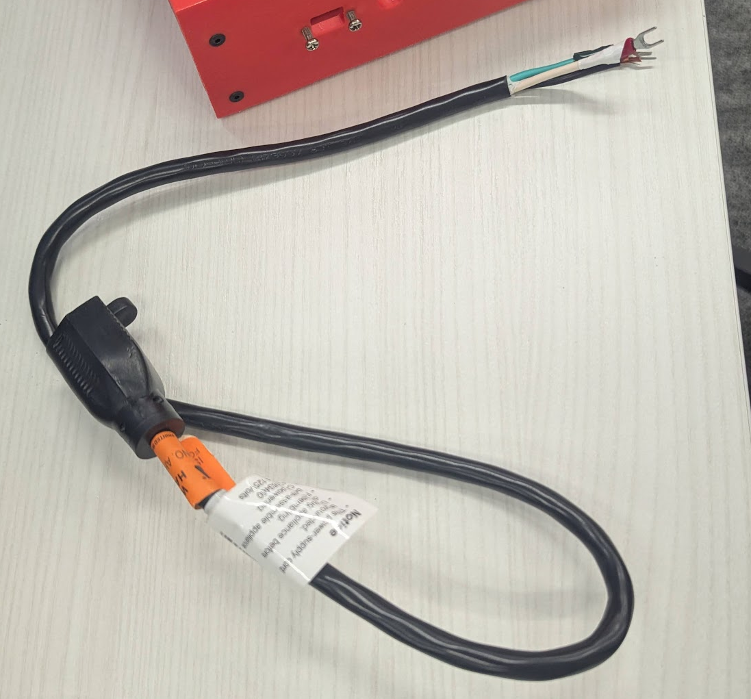
- Build cable E2: Power entry to power supply
  - With the excess cable from the previous step, cut a length of 15cm.
  - Strip off the entire black jacket to get 3 wires
  - For all cables on both ends (6 total), strip about 1cm
  - For all cables, crimp a quick disconnect connector [3X B32] on one end and crimp a spade connector [3X B31] on the other end.
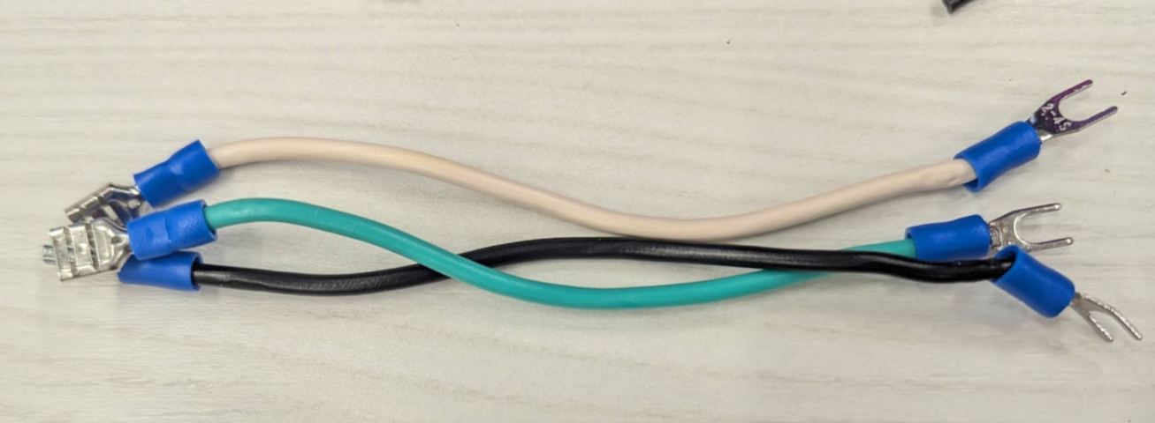
  - Connect the quick disconnect end of these wires to the back of the power entry connector [1X B22] as shown below. Connectors should snap in. The connector should be labelled N and ground. Black goes to top connection, white goes to N, and green goes to ground.
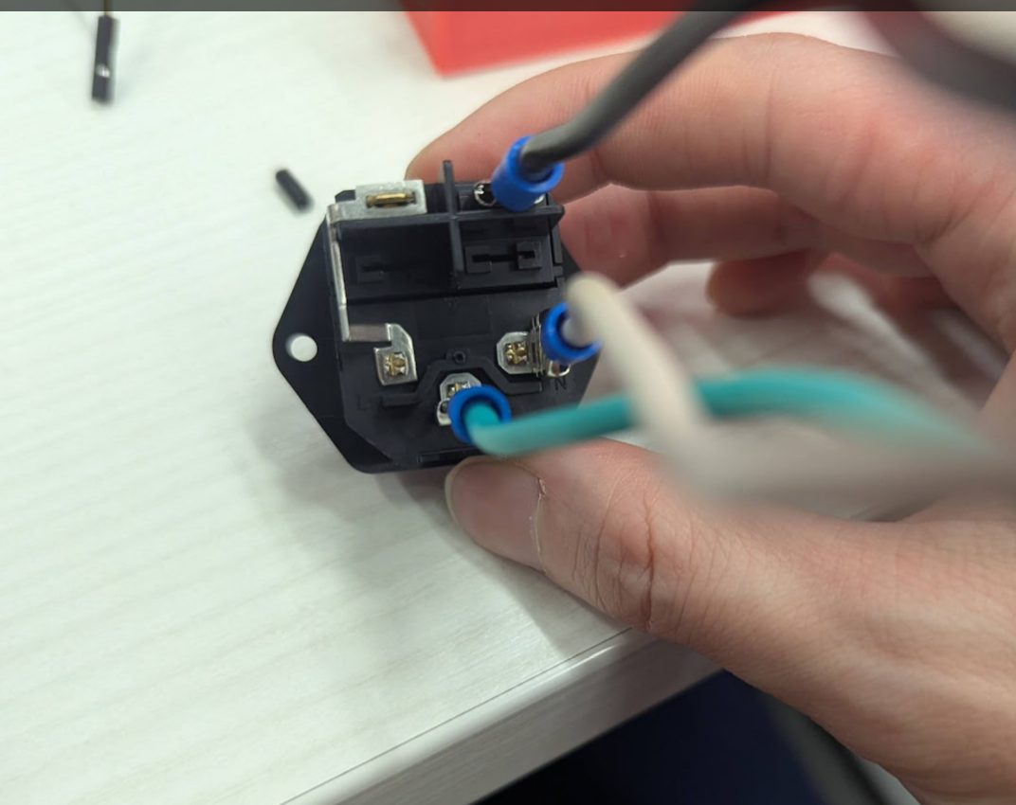
- Build cable E3: power supply to electronics
(Note: the image shows a different spade connector; use yellow instead.)
  - Take female jumper wires [3X B28]. These 3 wires will be for 5V, 12V and V-, so ideally you have a colours like black, red, and white.
  - For each wire, measure 20cm from one end of the female header and cut off the end.
  - For each wire, strip the bare end about 1cm.
  - For each wire, crimp on a spade connector [3X B30]. Note that if the crimp is not secure, solder this connection (or find a spade connector that accepts 28 AWG).
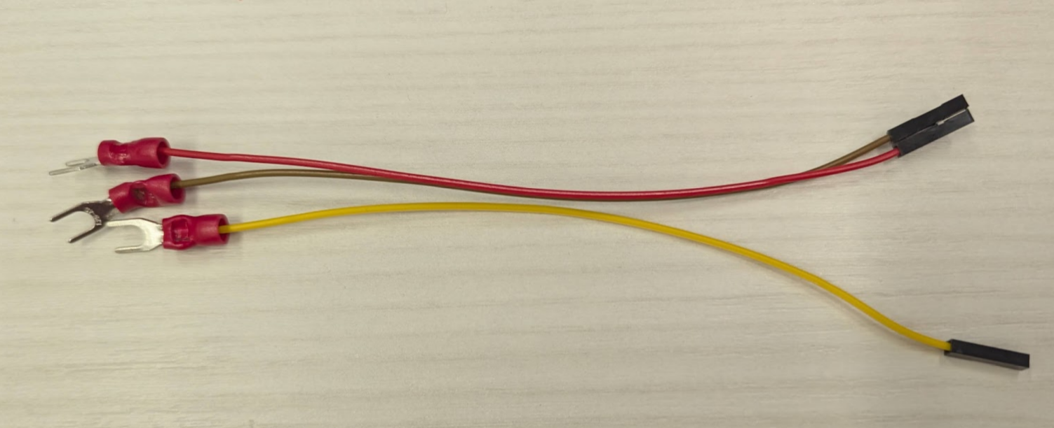
- Build cable E4 and E5: relay neutral cables
  - Take a spool of black 22 AWG stranded wire [B35]. Cut 2 wires, both 25cm in length.
  - For both wires, strip both ends about 1cm. (One of these cables [E5] is complete at this stage)
  - For only one of the wires, crimp a spade connector [1X B31] on one end. This cable is complete [E4].

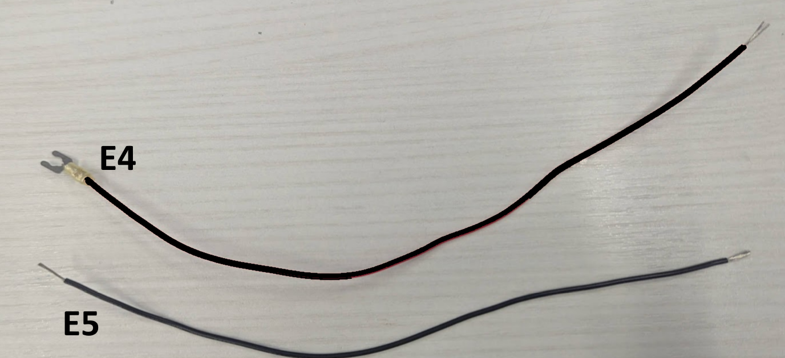

Section 3: Assemble the inner base

- Instal the pair of drawer slides [1X B19] to the inner base [1X C8] with M4x6mm button screws [12X B3]. These rails need to be extended fully to install the screws from the inner face. Note the orientation from the image below. The slides extend away from the heat set inserts on the back panel.
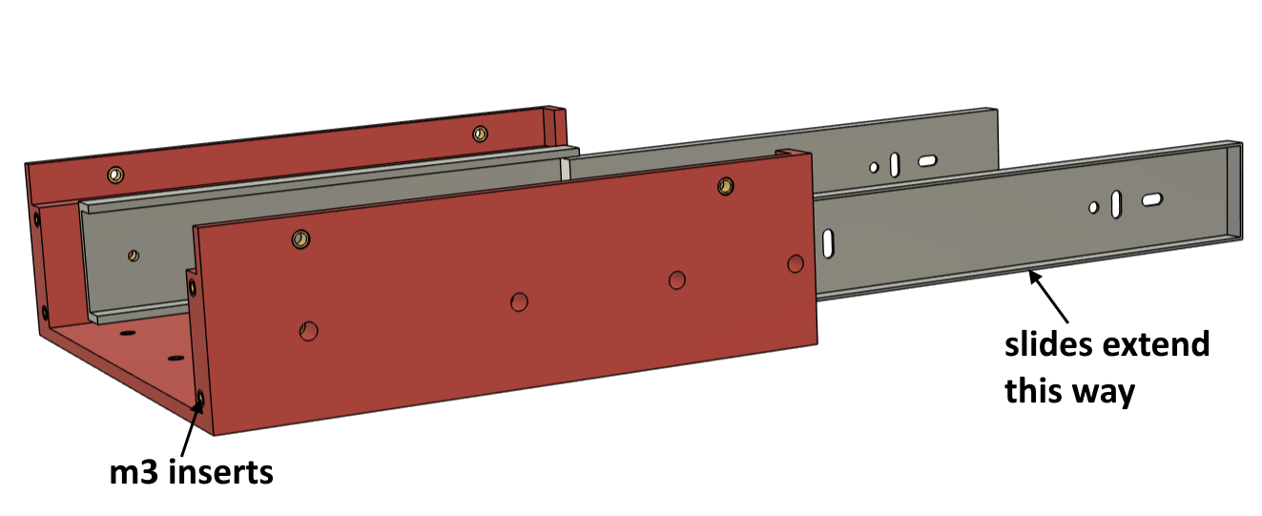
- Install the power supply [1X BX20] to the electronics mounting plate [1XC4] with M3X10mm flat head screws [2X B3]
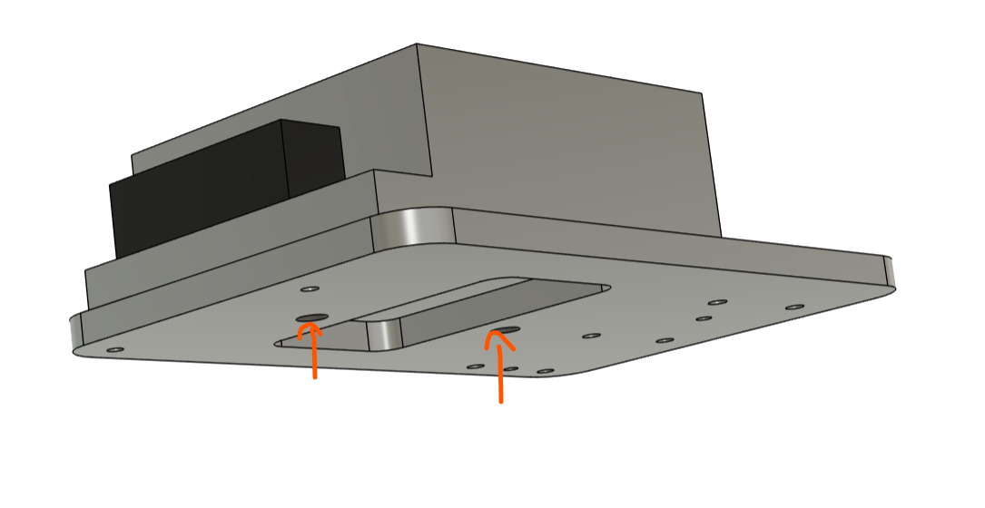
- Install the power supply and plate to the inner base using M3x10mm flat head screws [2XB3]. Note the power supplies terminal are facing at the back. They really should be installed with 4 screws, but 2 screws are blocked by the power supply. This design should have been temporary anyways.
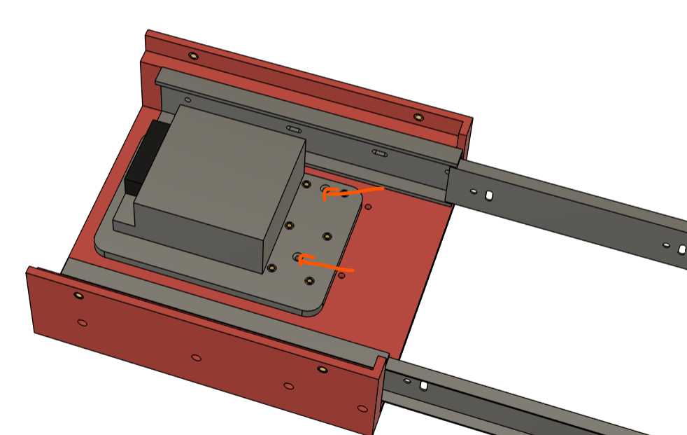
- Mount the electronics.

Section 4: Attach actuators to slides
- Take both actuators [2X B26] and extend them. There are a few ways to do this. The easiest way is to directly connect the actuators to a 12VDC power supply (V+ and V-). If it’s plugged in and the actuators don’t move, reverse the wires to extend.
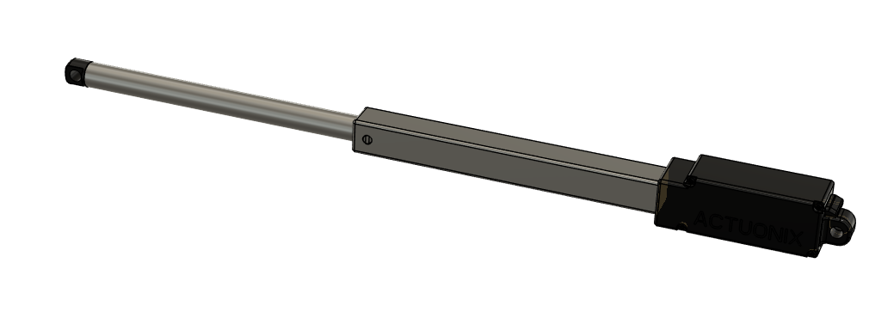
- Install the actuator mounting bracket [1X C2] to attach the 2 actuators together. The mounting bracket should slide over the shaft/housing of the actuators. Do this one at a time. Ensure that the bracket is touching the black faces of both actuators as indicated below.
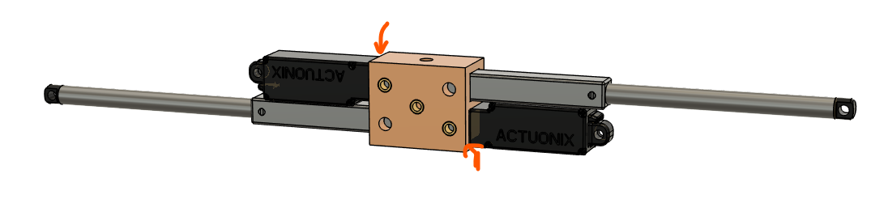
- Secure the actuators to the bracket with M4 set screws [4X B7]. Theres should be 2 set screws installed for each actuator, 1 on each side.
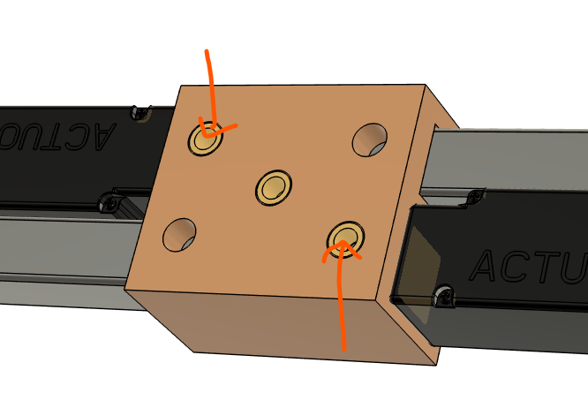
- Install a cable tie mount [1X B15] to the middle hole of the actuator mounting bracket using an M4x6mm screw [1X B3].
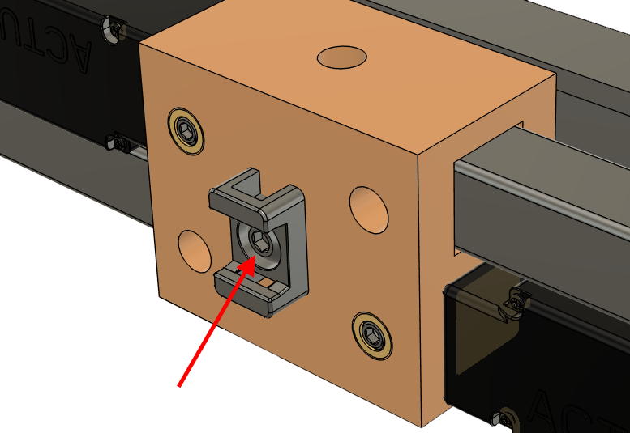
- On the right drawer slide, install the #8-32 6in screw [1X B1] and secure with an 8-32 locknut. The Actuonix actuators come with mounting hardware, which includes #8-32 locknuts. Use a different locknut (such as one with a lock washer) for easier assembly. This screw is installed into a slotted hole in the drawer slide, and positioning will need to be adjusted in a later step.
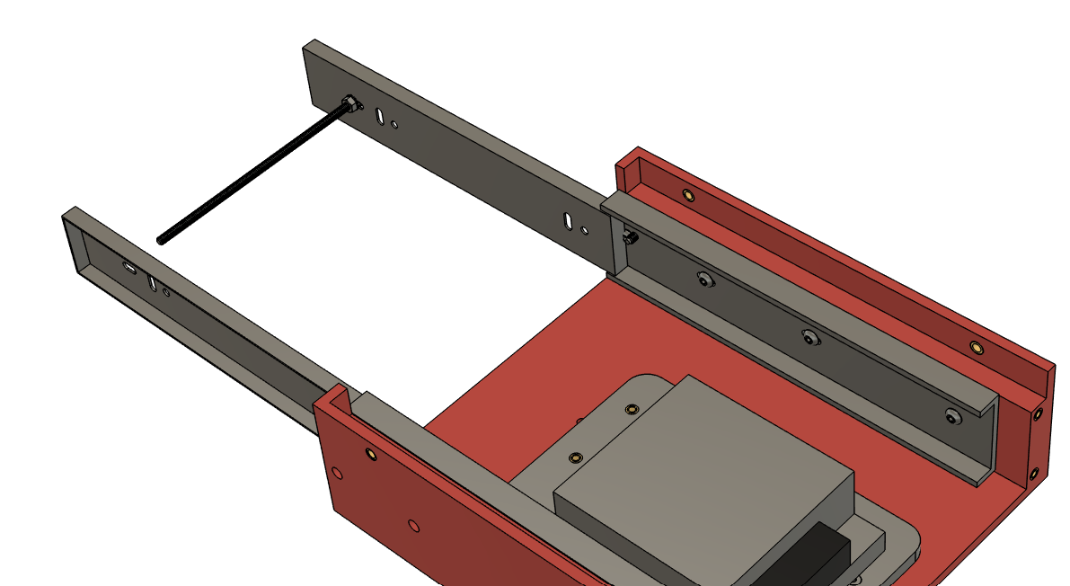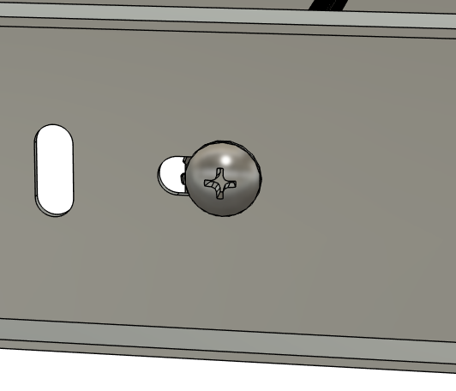
- Slide the actuator assembly over the long screw. Note the orientation of the assembly from the image below.
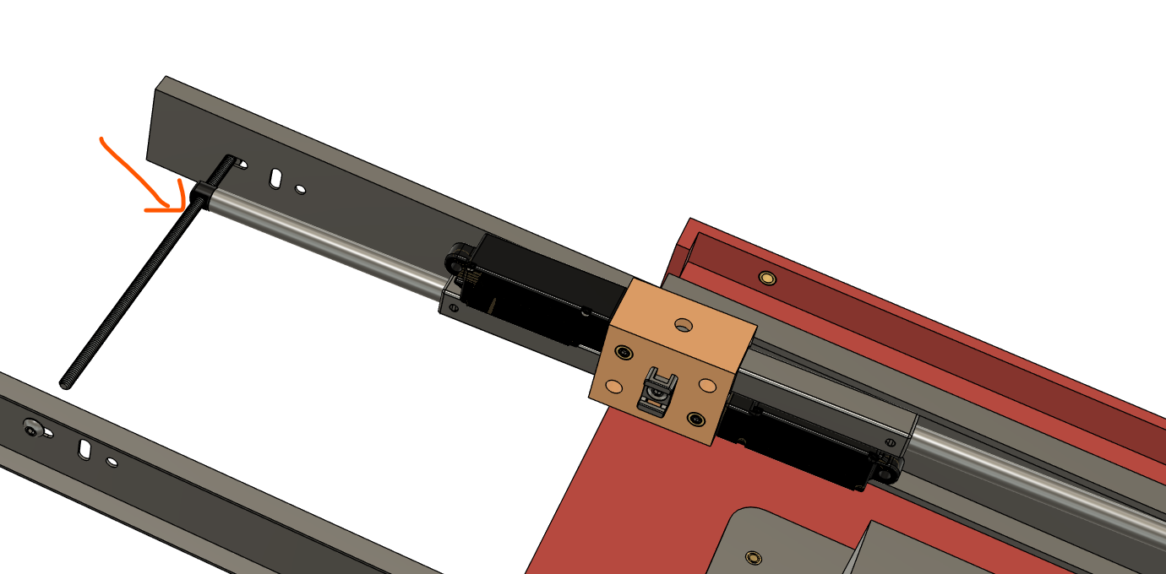
- Retract the drawer slides to a position as shown below.
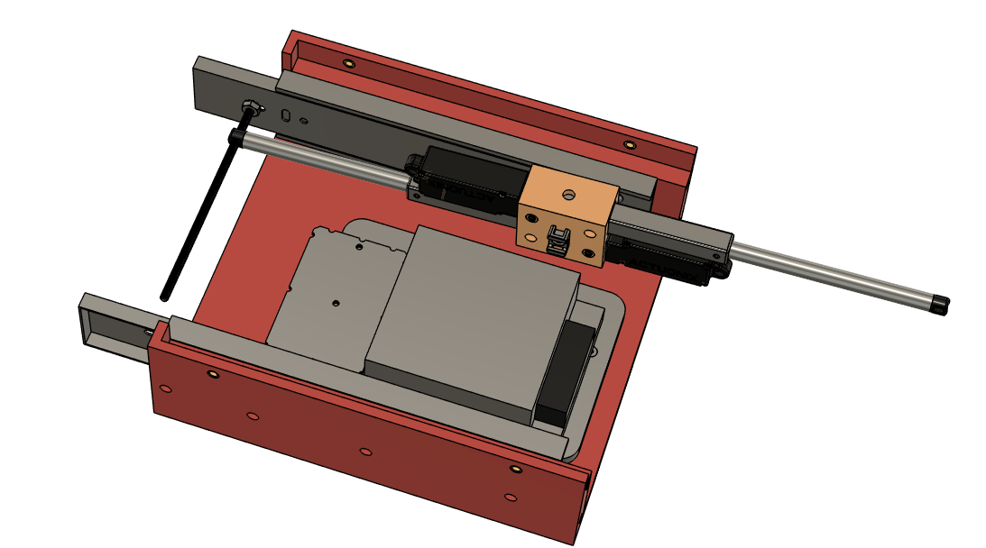
- Install the thread adapter [1X B14] on the left side with threadlocker [B17]. Note that the nut on the right side to secure the screw will probably need to be loosened to allow for the thread adapter to be installed. Install the thread adapter so it is touching the left drawer slide’s inner face. Re-tighten the right nut if necessary.
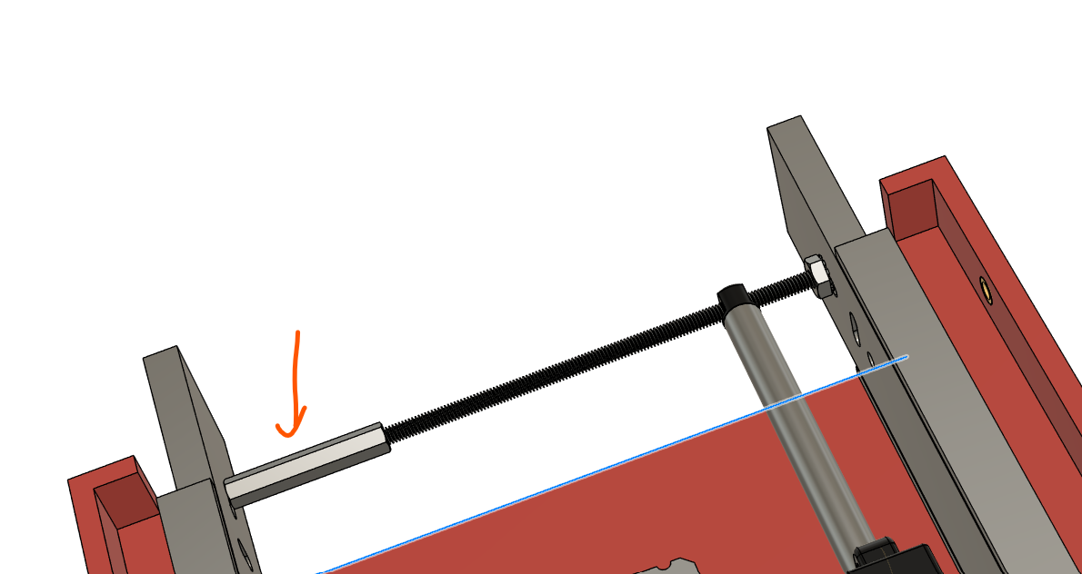
- Install an M4 x 6mm long screw [1X B3] on the right drawer slide to secure the thread adapter/long screw. Use threadlocker [B17]. After this is installed, ensure that the drawer slide can freely slide in and out. If not, readjust the positioning of the thread adapter.
